Module 3

Assignment 3.2
Course: CSD402-340A Java for Programmers
Prepared By: Mirach Erkol
Date of Report: 1/25/2025

https://github.com/Mikey5007/CSD340.git

3.2 Assignment: HTML Validator
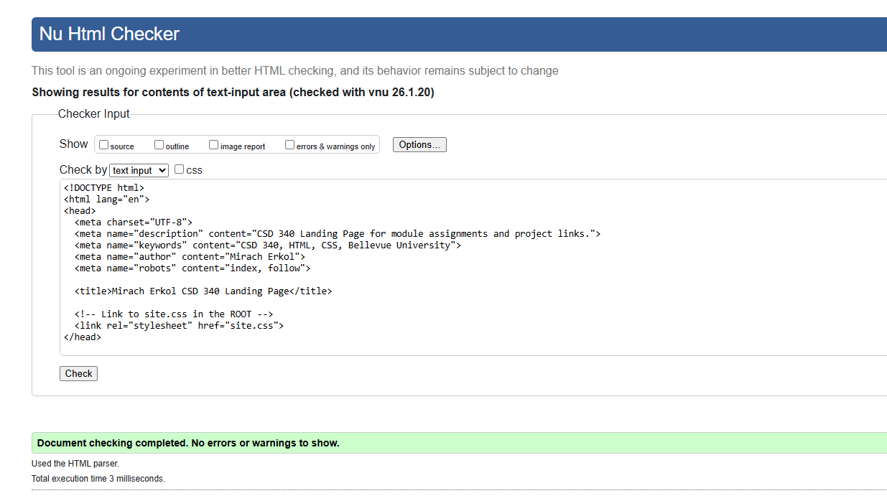
3.2 Assignment: CSS Validator
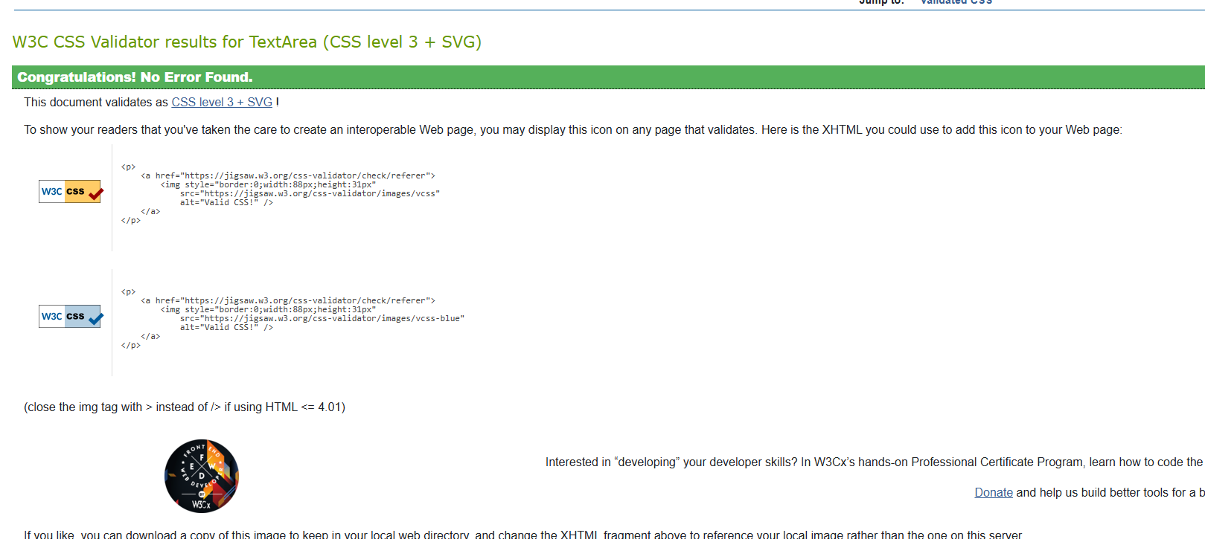

3.2 Assignment: Index.html Open in Browser

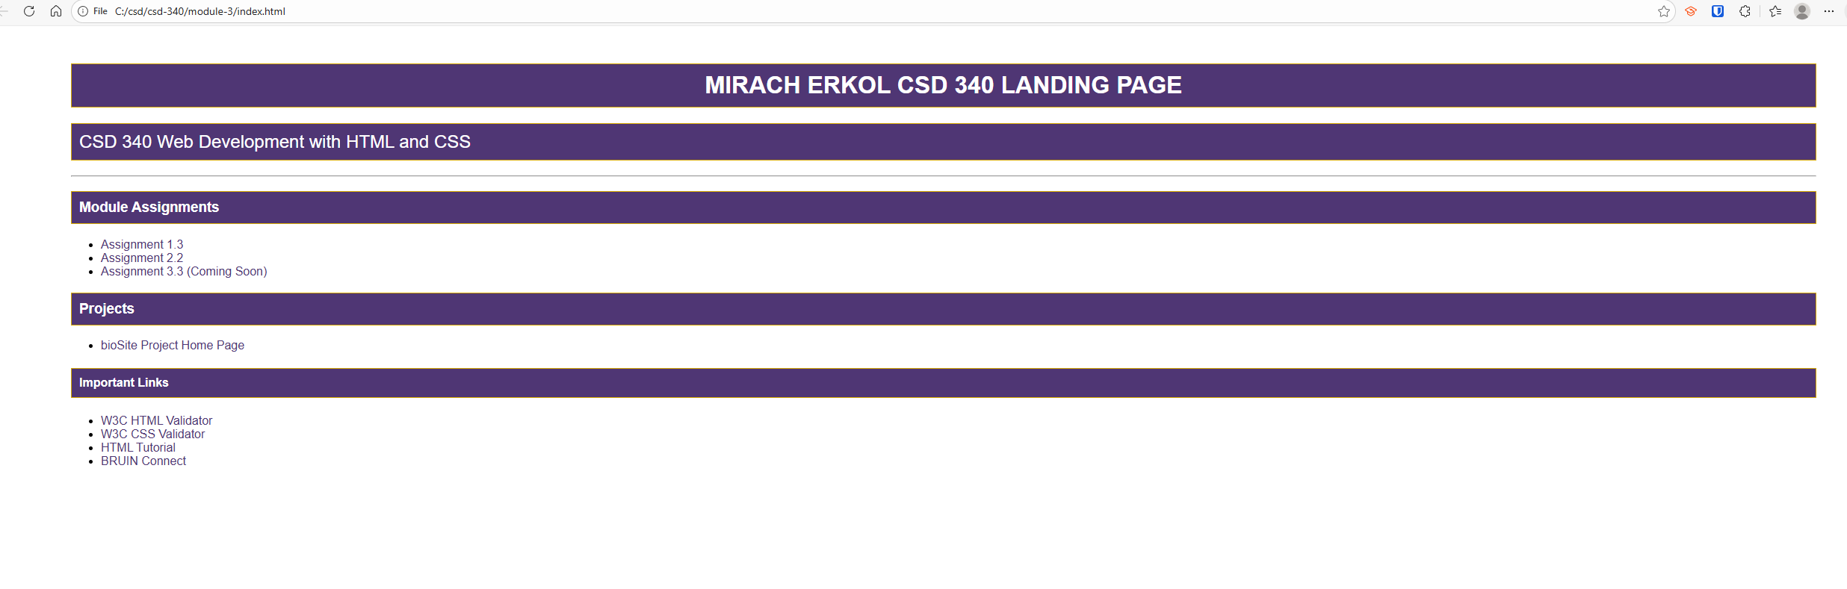

3.2 Assignment: GitHub Page

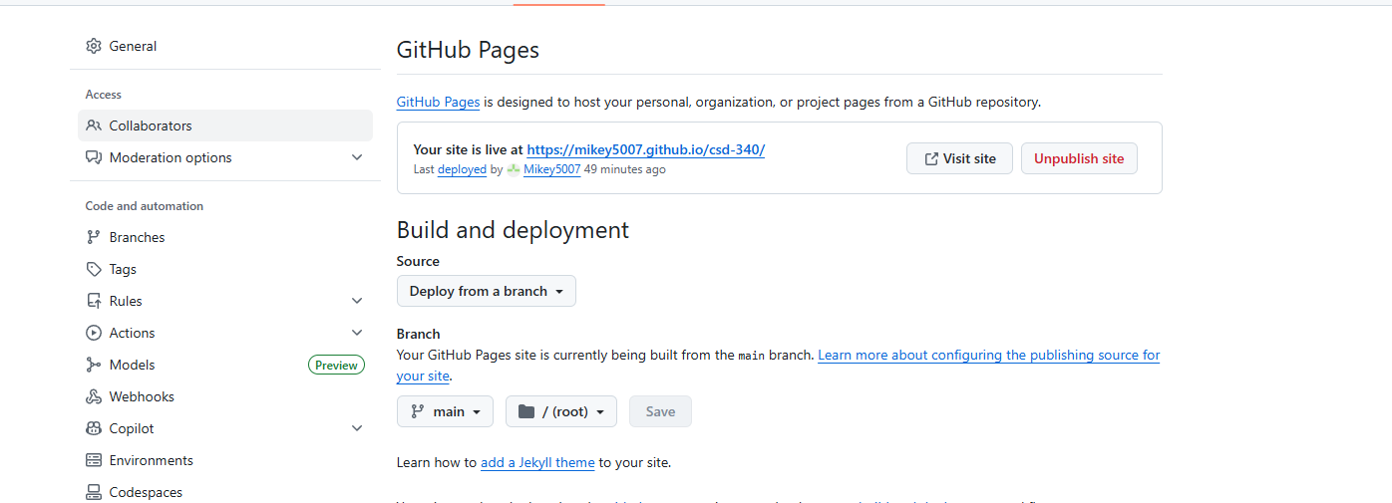

References:

https://github.com/Mikey5007/CSD340.git

